Name: | Bodhisatya Ghsoh
Class: | CSE DS
Batch: | B
UID: | 2021700026
Experiment no: | 9

Aim: Installation and Configuration of SMTP Server:

Given below are the steps to achieve the aim mentioned above

Part A: Changing hostname

Step 1: Open Terminal

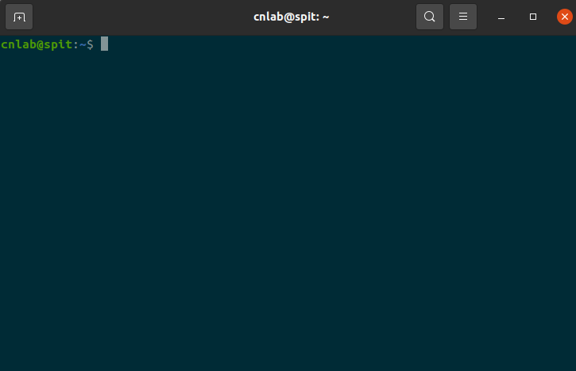

Step 2: Change Hostname to Custom Domain name using sudo hostname <hostname>

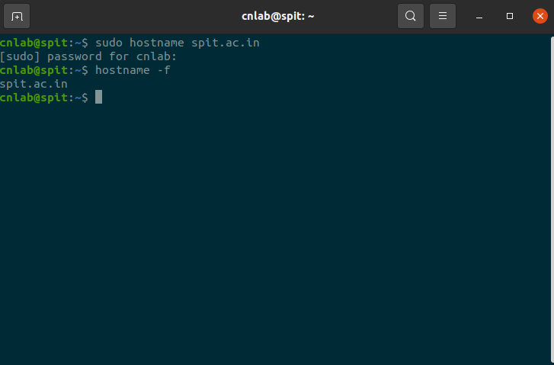
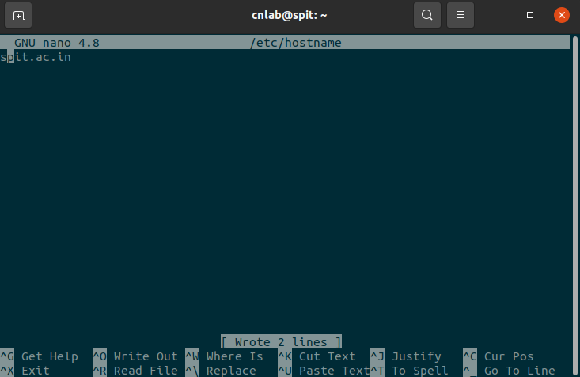
Step 3: Use sudo nano /etc /hostname and enter domain name before saving file
Step 4: Change value in front of 127.0.1.1 to spit.ac.in

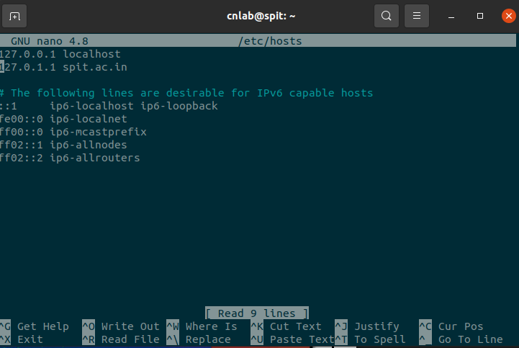
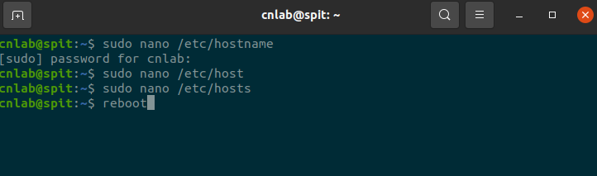
Step 5: Reboot system to save changes
PART B: Installation of postfix
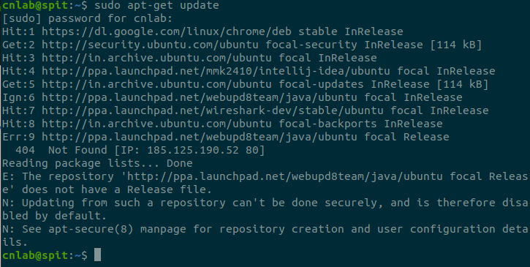
Step 1: Run sudo apt-get update to update all packages
Step 2: Use sudo apt-get install postfix to install postfix with other mail utilities
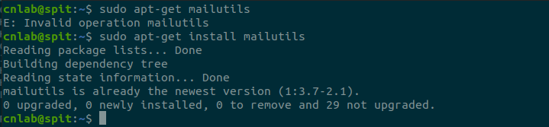

Step 3: Select Internet Site during configuration as we need smtp

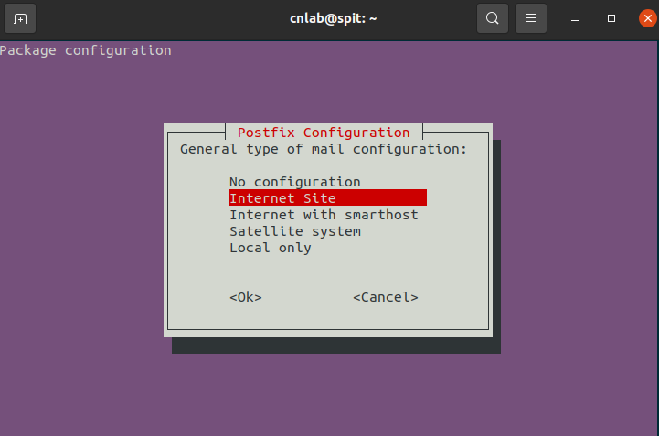
4. Configure postfix in order to send email to a patricular email address
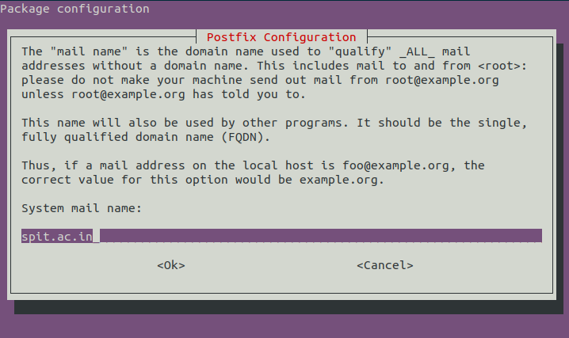
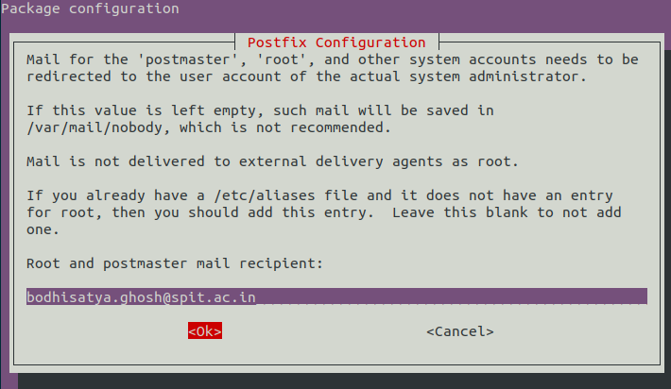

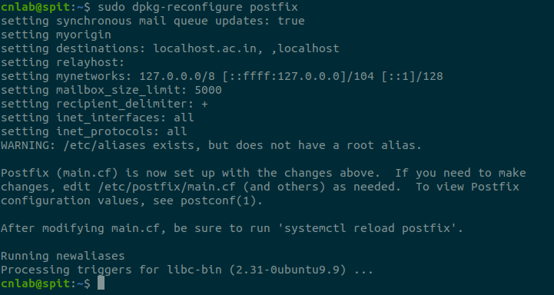

PART C: Configure postfix with Gmail SMTP

Step 1: Run sudo nano /etc/postfix/main.cf Command And Add relayhost = [smtp.gmail.com]:587.

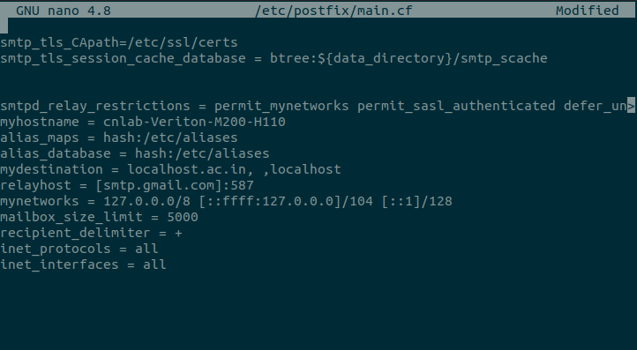
Step 2: In Above File Add Contents Of https://docs.google.com/document/d/1y_xQ9nrVT8Yf3GmhQRt-
cdhcm1FwVrXf_L6n_iwz6Xc/edit?usp=sharing.
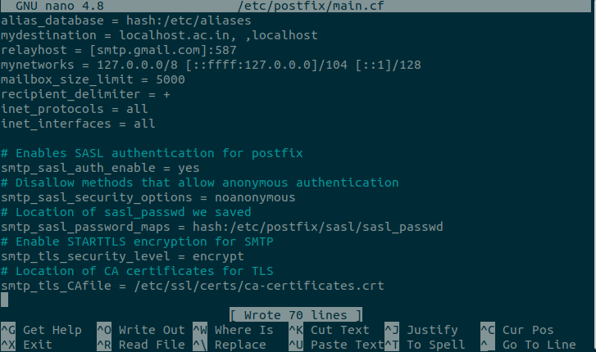

Step 3: In Same File Delete Everything Next To “mydestination =” Except “localhost<your_hostname>,
,localhost” And Save The File.
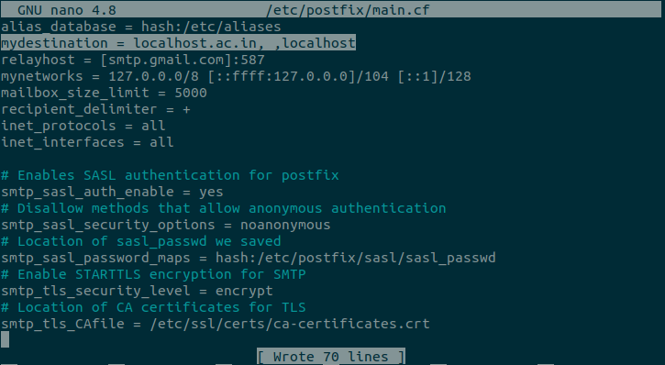
Step 4: Create New File Using sudo nano /etc/postfix/sasl/sasl_passwd Command, Add
[smtp.gmail.com]:587 email_address :password And Save The File.
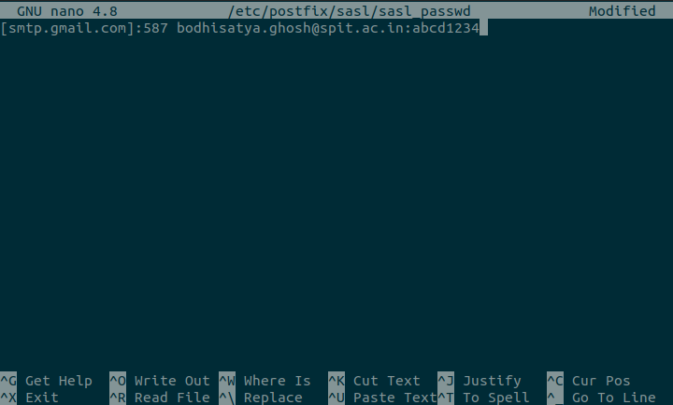

Step 5: Convert The sasl_passwd File Into A Database File Using sudo postmap
/etc/postfix/sasl/sasl_passwd Command.
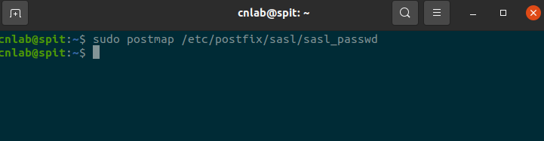
Step 6: Restart Postfix Using sudo service postfix restart Command.
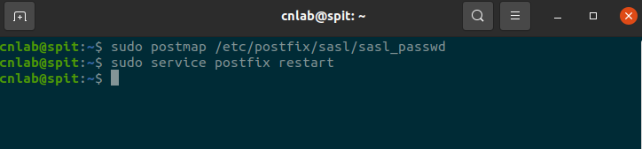

Step 7: Change The Setting In Google Account To Allow Less Secured Non-Google Apps To Use
Authentication To Send Emails Via SMTP On Your Behalf.
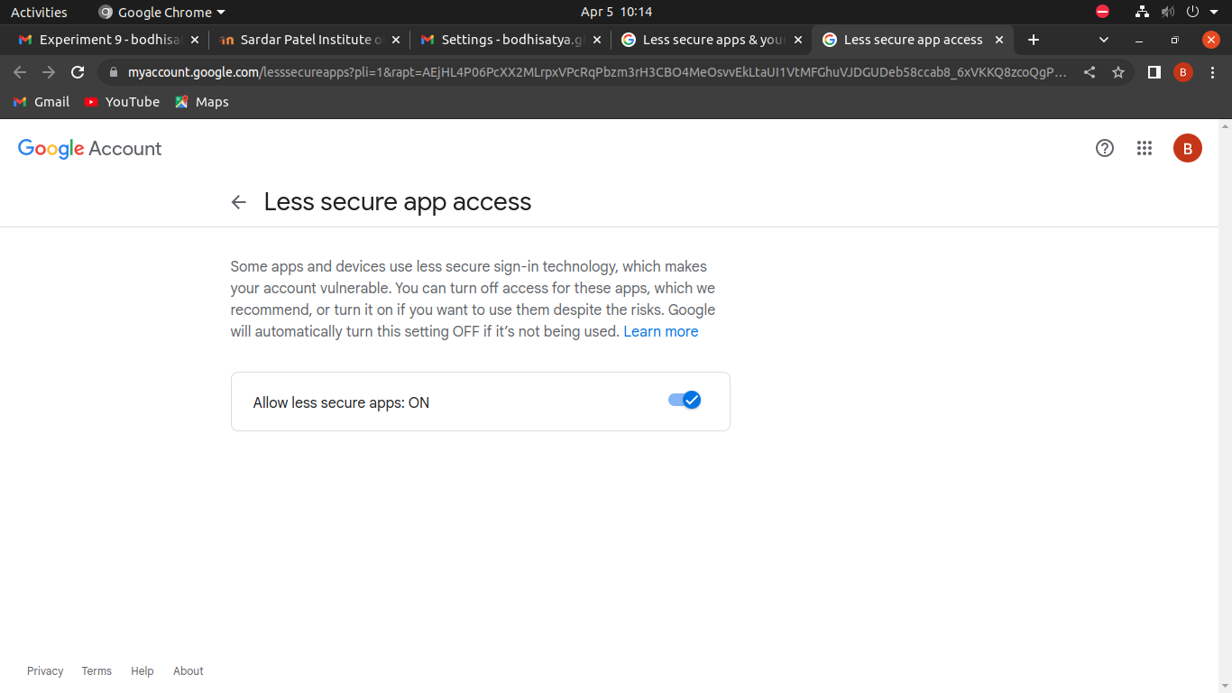

PART D: Sending and recieving mail

Step 1: Send Email Using echo "<Message>" | mail -s "<Title>" <email_address> Command.
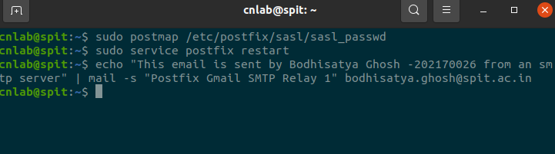
Step 2: Open Gmail And Check The Received Mail.
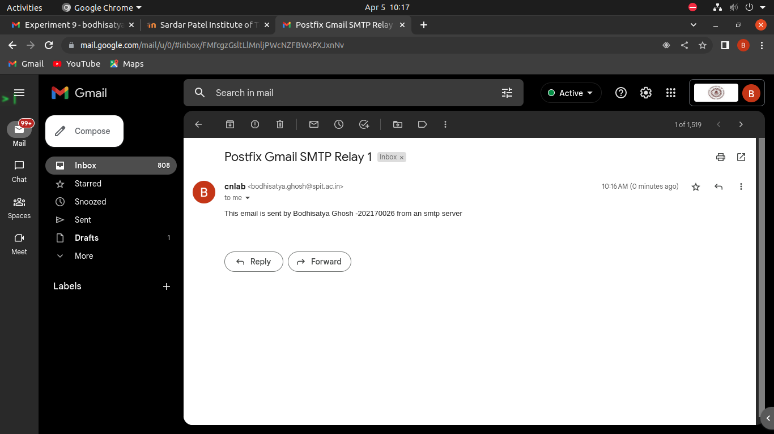
Conclusion: In this experiment we learned that SMTP stands for Simple Mail Transfer
Protocol, and it’s an application used by mail servers to send, receive, and/or
relay outgoing mail between email senders and receivers. We saw working Of SMTP and also learned that Postfix is the default Mail Transfer Agent (MTA) in Ubuntu. We saw steps to install and configure SMTP Server using Postfix And successfully sent A mail. Thus we studied SMTP Server Configuration using Postfix.

